LLM
UNIT – 1
Part -c :
- Analyze the complete life cycle of a Large Language Model, including architecture design, pretraining, fine-tuning, inference, and optimization challenges.
Answer:
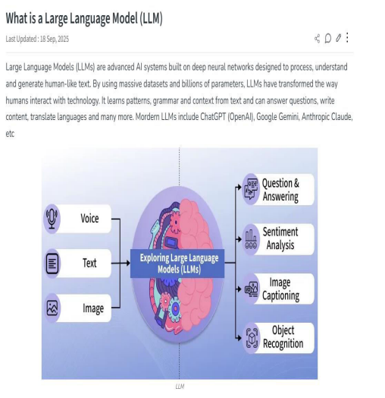
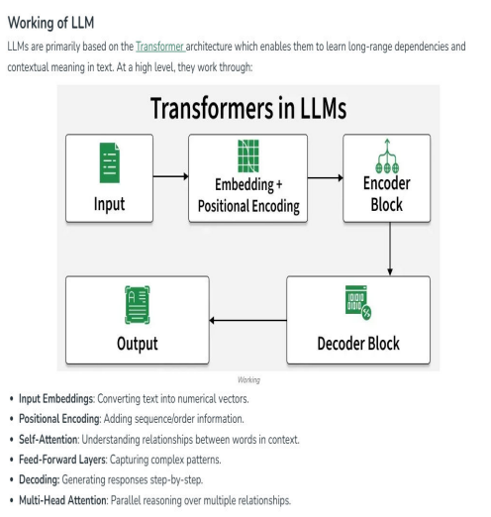
- Architecture:
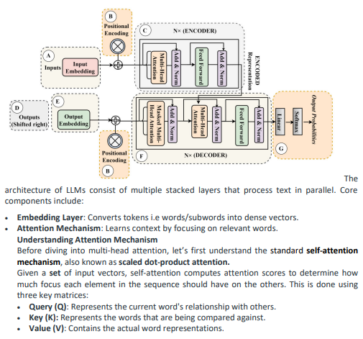
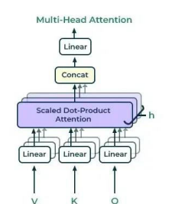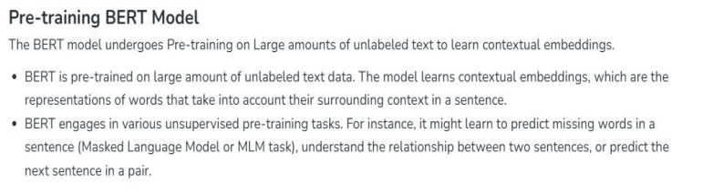
- PRE- TRAINING :
Pretraining Phase During pretraining, the model is trained on massive amounts of unlabeled text data to learn general language patterns, semantic representations, and syntax. Because the model is learning the foundational rules of language, the primary evaluation metric used during this phase is Perplexity. Perplexity measures the model's uncertainty when predicting the next word; a lower perplexity score indicates higher confidence and better baseline language understanding
- FINE TUNING PHASE:
To adapt the generalized pretrained model for real-world NLP tasks, it undergoes fine-tuning using labeled, task-specific, or domain-specific data. Methods include instruction tuning, which trains the model on instruction-response pairs to improve task generalization, and domain adaptation, which tailors the model to a specialized field. Because full fine-tuning is computationally expensive, Parameter-Efficient Fine-Tuning (PEFT) techniques, such as LoRA (Low-Rank Adaptation) and Adapter-Based Tuning, are often used to freeze the base model and train only a tiny subset of parameters. The key metric in this phase is Accuracy, which evaluates how correctly the model performs its targeted tasks, such as question answering or classification
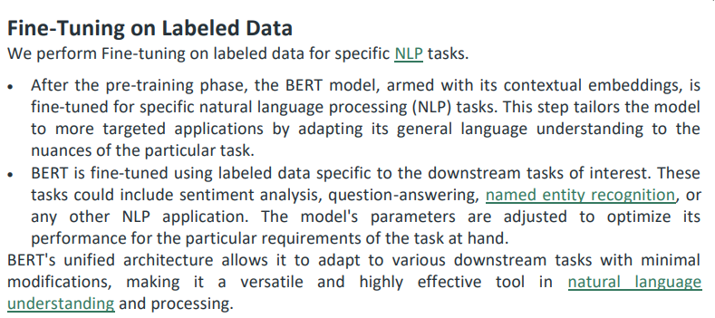

- INFERENCE PROCESS:
Inference is the deployment phase where the trained model processes user inputs and generates predictions or text, often autoregressively token-by-token. The critical performance metrics during inference are:
Latency: The time taken to generate a response after receiving an input (crucial for real-time user experience).
Throughput: The overall capacity of the system, measured by the number of tokens or requests processed per second.
- Optimization Challenges & Solutions:
The massive scale of LLMs introduces severe memory, scalability, and Compute Cost challenges—the hardware (such as highly parallel GPUs and TPUs) and energy required for training and inference are immense. Large model sizes limit deployment environments and slow down inference. To overcome these challenges, several optimization techniques are deployed:
Model Compression: Techniques like Pruning (removing unnecessary network weights/neurons), Quantization (reducing the numerical precision of weights to save memory), and Knowledge Distillation (transferring knowledge from a massive "teacher" model to a smaller "student" model) drastically lower memory requirements and improve latency and throughput while attempting to maintain accuracy.
Training Optimizations: Strategies like Mixed Precision Training (using low and high precision formats to accelerate speed) and Gradient Checkpointing (saving memory by recomputing activations instead of storing them) keep GPU memory limits manageable. Memory-efficient optimizers, such as Adafactor and LAMB, are also heavily utilized to handle massive batch sizes without crashing the system.

